**Experiment no – 02**

**Aim: Write a Program to Demonstrate working of threads.**

**Theory: -**

**What is a Thread in Java?**

A thread in Java is the direction or path that is taken while a program is being executed. Generally, all the programs have at least one thread, known as the main thread, that is provided by the JVM or Java Virtual Machine at the starting of the program’s execution. At this point, when the main thread is provided, the main() method is invoked by the main thread.

A thread is critical in the program because it enables multiple operations to take place within a single method. Each thread in the program often has its own program counter, stack, and local variable.

**Creating a Thread in Java**

A thread in Java can be created in the following two ways:

* **Extending java.lang.Thread class**

In this case, a thread is created by a new class that extends the Thread class, creating an instance of that class. The run() method includes the functionality that is supposed to be implemented by the Thread.

Below is an example to create a thread by extending java.lang.Thread class.

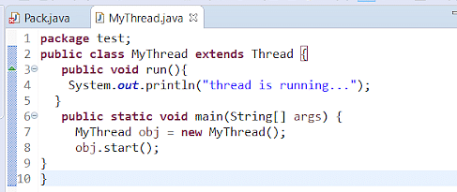

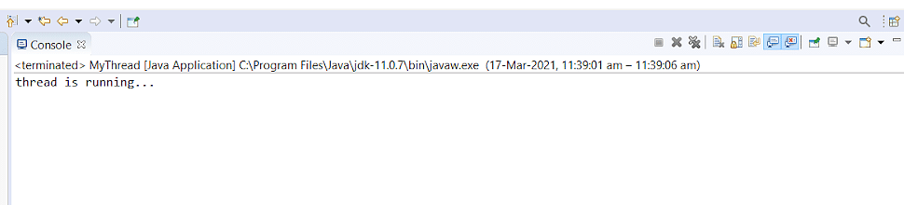

Here, start() is used to create a new thread and to make it runnable. The new thread begins inside the void run() method.

* **Implementing Runnable interface**

This is the easy method to create a thread among the two. In this case, a class is created to implement the runnable interface and then the run() method.

The code for executing the Thread should always be written inside the run() method.

Here's a code to make you understand it.

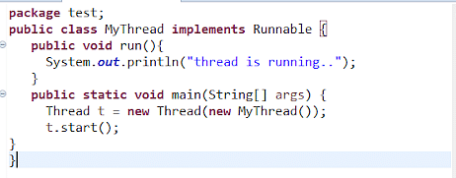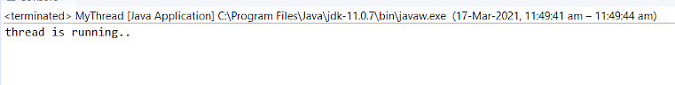

The start() method is used to call the void run() method. When start() is called, a new stack is given to the thread, and run() is invoked to introduce a new thread in the program.

**Program: -**

**progam.java**

class ABC

{

synchronized void print()

{ int a=0;

System.out.println("hi");

System.out.println("I");

System.out.println("am");

++a;

try{

Thread.sleep(500);

}

catch(Exception e)

{

}

System.out.println("Learning"+a);

System.out.println("Java");

}

}

class myprog extends Thread

{ ABC ob1;

myprog(ABC ob)

{

ob1=ob;

}

public void run()

{

ob1.print();

}

}

class mainprog

{

public static void main(String args[])

{

ABC ob = new ABC();

myprog t1=new myprog(ob);

myprog t2=new myprog(ob);

t1.start();

t2.start();

}

}

**Output:**

